Dominican College will be hosting its 4th. annual baseball prospect camp on Saturday October 15, 2011 at 9:00 at Tappan Zee HS in Orangeburg, NY (rain date Sunday October 16). The cost of attending the event will be $75.00. We are also planning on inviting coaches from other area colleges to attend & evaluate the players in attendance. **Please note: you must bring with you an updated physical from you doctor in order for you to participate in the camp.

The format for the camp is as follows:
Check in (arrive between 8:30-8:45, we planning on starting the camp at 9:00 sharp)
60 yard dash
Outfielders – fielding and throwing Infielders – fielding and throwing
Catchers – throwing to 2nd and 3rd and fielding bunts
Pitchers throwing in the bullpen
Batting Practice
Modified live scrimmage (if time permits)

What To Bring for camp: Baseball attire (baseball pants, hat, glove, spikes, bat, preferably wood, if possible) & most important, a physical from your doctor.

PLEASE NOTE: Dominican College will also be holding its fall Open House beginning at 1:00. So, this would be a great opportunity to not only show off your baseball skills but get a chance to meet with our Admissions Office & the faculty & staff at Dominican & tour the campus.

For further information please contact Dominican Associate Baseball Coach Chad Duesler @ (O) 845-848-7705 or email: chad.duesler.@dc.edu.

Tappan Zee HS
15 Dutch Hill Road, Orangeburg, NY 10962
(The baseball field is located behind the HS)
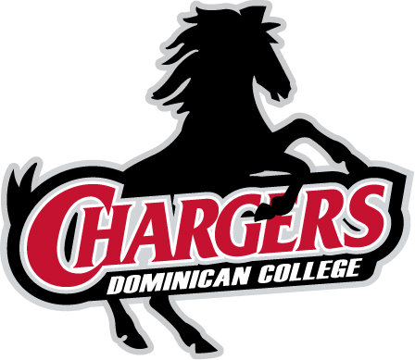

** Tappan Zee HS is located directly across the street from Dominican College.

